Pokhara University

Level: Bachelor | Semester – Spring | Year : 2006
Programme: BE |  | Full Marks: 100
Course: Electromagnetic Fields and Waves |  | Time : 3hrs.

Candidates are required to give their answers in their own words as far as practicable.
The figures in the margin indicate full marks.

Attempt all the questions.

 | - State Coulomb's law. Use it to find the electric field due to a line charge with current density ρ_{L} C/m.  - Infinite uniform line charges of 7nC/m lie along the (positive and negative) x and y-axis in free space. Find 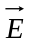 at P(0, 2, 3). | 8  7
 | - Determine an expression for the volume charge density associated with the field 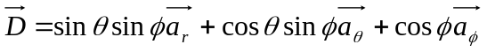  OR  Define divergence of a vector . Also give its physical significance.  - What do you mean by a conservative field? Prove that the static electric field is conservative.  - What do you mean by polarization? Write the expression relating 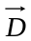 and. | 5  5  5
 | - Two conducting cones (θ = π/10 and θ = π/6) of infinite extent are separated by an infinitesimal gap at x = 0. If V(θ = π/10) = 0 and V(θ = π/6) = 50 V, find V and between the cones.  - A circular loop located on x² + y² = 9, z = 0 carries a direct current of 10A along 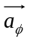. Determine 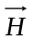at ( 0, 0, 4).  OR  State Biot-Savart Law. Using Ampere's circuital law, find the magnetic field due to an infinitesimal current carrying conductor. The current flowing through the conductor may be assumed to be I and the conductor is placed along z-axis. | 5+3  7  7
 | - The current density is given as . Find the total current passing through the spherical cap 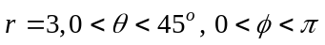 in the 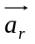 direction.  - State Maxwell's equation in point form, integral form and time harmonic form for time varying electromagnetic fields. | 7  8
 | - In free space (z≤0) a plane wave with 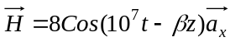 mA/m is incident normally on a lossless medium (ε = ε₀, μ = 7μ_{o}) in the region z≥0. Determine the reflected wave 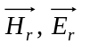 and transmitted wave 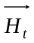 and 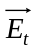.  - A (75+j125)Ω load is connected to 72Ω lossless line. Find  - Γ  - s  - The load admittance, Y_{L}.  - Z_{in} at 0.3λ from the load (using smith chart). | 8  7
 | - What do you mean by skin effect? Discuss the radiation pattern of a dipole antenna.  - In a nonmagnetic medium, 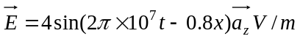, Find (i) E_{r}, η (ii) time average power carried by the wave.  OR  Explain the propagation of EM waves in free space with necessary derivations. | 8  7
 | Write short notes on (Any Two):  - Wave guides  - Displacement current  - Curl  - Uniqueness theorem | 5×2

